Instructions for Editing KStars Code on OS X using QT Creator.

1. Install KStars using the KStars on OS X Craft build script. It doesn’t matter which options you use as long as you don’t install the “stable” build because that would put your edits out of date with the rest of the repository.

<https://github.com/rlancaste/kstars-on-osx-craft>

1. Open QT Creator. If that is not installed yet, please see the QT website: <https://www.qt.io/download-qt-installer>
2. In Preferences, Select Kits: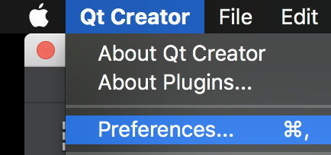 
3. Add the Craft CMAKE executable to the list of CMAKE executables in the cmake tab. 
4. To do this task, Click  and then 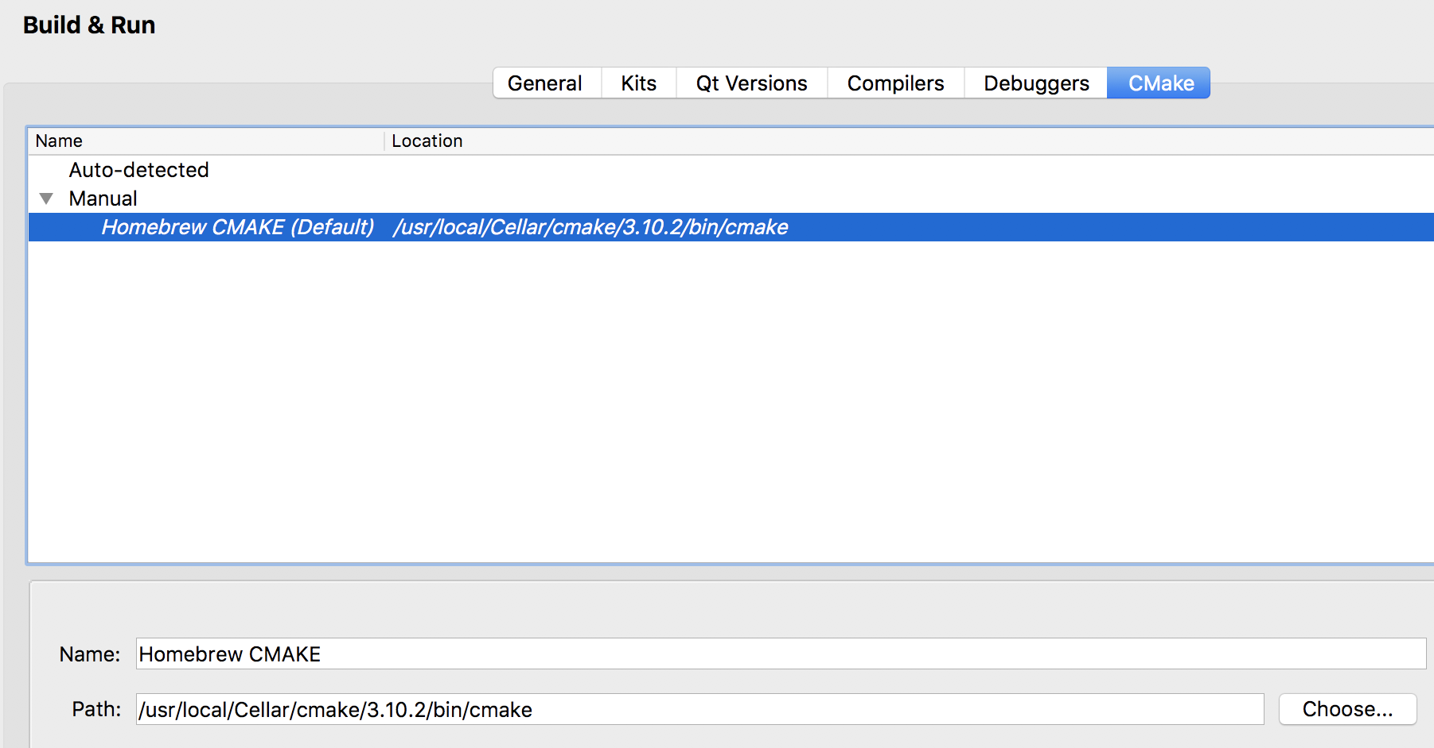 to find the path to CMake in Craft you will probably find it somewhere like this. Remember the name you give it since you will need it shortly in the next step:



1. Add the craft Qt version to the list of QT Versions if it is not in there yet. Click QT Versions



1. If the version in craft is not added, yet, click add and choose the directory.



1. Select Kits:



1. Click Add to configure a new Manual Kit. 
2. Select the following Options:

Note: The QT Version may differ depending on your QT installation and the Make tool you select should be the one you added in the step before.

1. Now set up the CMake Generator by clicking the Change button.



You will need to select the following options:



1. Finally setup the CMake Configuration by clicking the Change Button:



1. You will need to set the following options, add your craft root as shown:

CMAKE_CXX_COMPILER:STRING=%{Compiler:Executable:Cxx}

CMAKE_C_COMPILER:STRING=%{Compiler:Executable:C}

CMAKE_INSTALL_PREFIX:STRING=~/AstroRoot/craft-root

CMAKE_PREFIX_PATH:STRING=%{Qt:QT_INSTALL_PREFIX};~/AstroRoot/craft-root

QT_QMAKE_EXECUTABLE:STRING=%{Qt:qmakeExecutable}

1. Finally click ok. 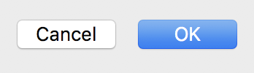
2. Note that you might also need to install ninja in Homebrew. Just type brew install ninja on the command line.
3. Now, Click Open Project 
4. Navigate to and Select the KStars CMakeList.txt. Here is the path it will probably be at:

~/AstroRoot/craft-root/download/git/kde/applications/kstars/CMakeLists.txt

Note that you can use the craft shortcuts: ~/AstroRoot/craft-shortcuts/kstars-source

1. Configure the project by selecting your custom “Craft Kit” and deselecting the default one. Also, you will need to deselect most of the build options and just use the default one.

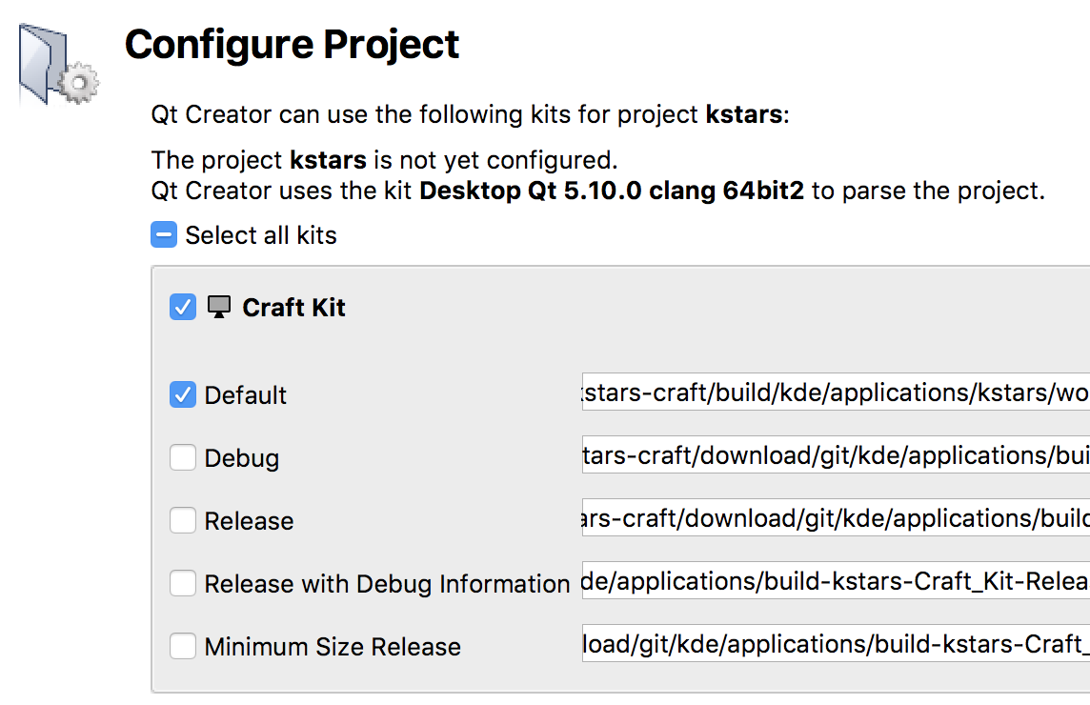

1. Select 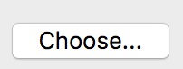 next to the Default Kit to select the path to the build folder. On your system, the correct path is probably:

~/AstroRoot/craft-root/build/kde/applications/kstars-mac/work/RelWithDebInfo-Latest

Note that you can also use the craft shortcuts: ~/AstroRoot/craft-shortcuts/kstars-build

1. Click the Configure Button:

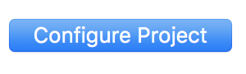

1. Now you might get a popup dialog that looks like the following:

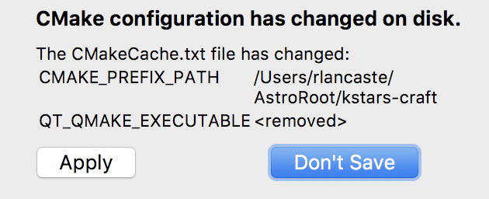

1. I clicked “Don’t Save” to this Dialog, but I don’t know.
2. Now you should see all of the files pop up on the left. You can edit these to make your changes. Whenever you want to test your changes, just click the “Run” button on the left. KStars should be fully functional and editable on your Mac. Happy Coding!!

